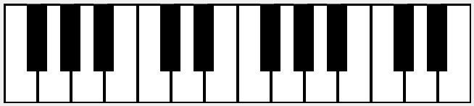

D

S

-

0

9

6

7

4

3

2

X

Z

]

[

P

O

I

U

Y

T

R

E

W

Q